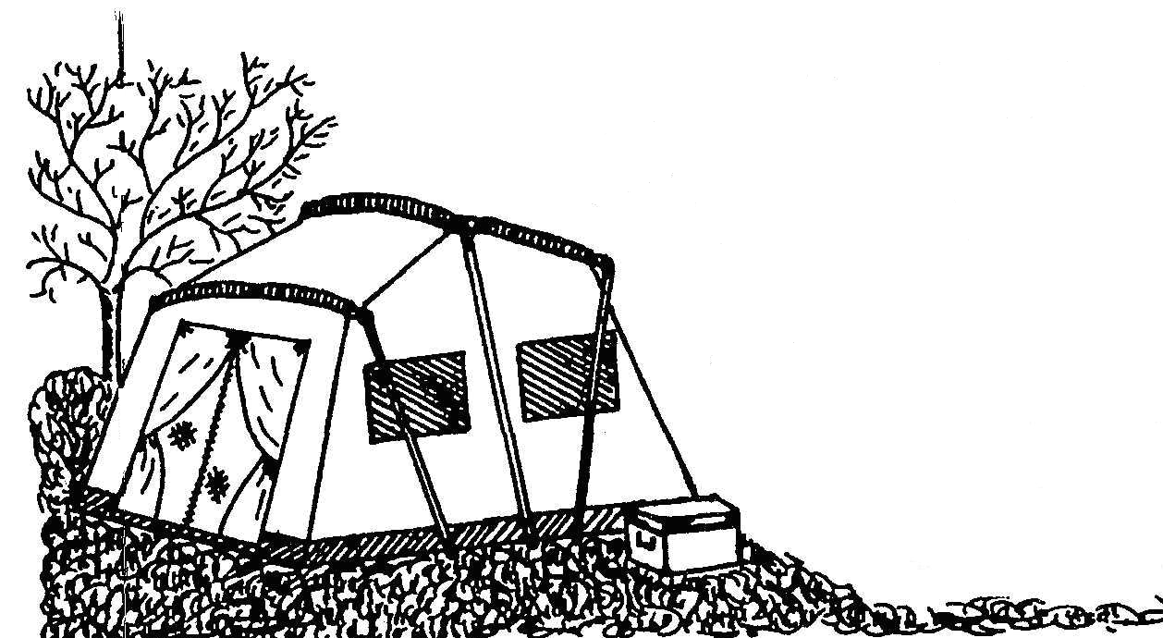
Memramcook Valley

BLUEGRASS FESTIVAL

JUNE 13, 14, 15, 2008

Close To Home (NS) ……………………………………….….… Fri, Sat, Sun
Bluegrass Diamonds (NB) …………….…………………………... Sat., Sun
The GrassKickers (NB) ………….….……………..………….. Fri, Sat, Sun
Janet McGarry & Wildwood (PEI) ……..…….....………… Fri, Sat, Sun
Highway Bound (NB) …………………………………..………. Fri, Sat, Sun
Christine Cormier and Step Dancers (NB) ……..………………….… Sat
New Grounds (NS) ……………………………………………………….Fri, Sat
Gospel Connection (NB) ……………………………………..………….… Sun
MC’s Gerry Murphy *** Serge Bernard *** Francis Cormier

Show Times: * Friday 6:30 – 10:20 *Saturday 10:00 – 10:20 *Sunday 10:00 – 3:00
Admission (per person)
Early Bird Camping $5.00/Day till Wednesday
Weekend Pass $35.00 (camping included)
Friday Night Only $12.00
Saturday Afternoon (12h-5h) $12.00
Saturday All Day $25.00
Saturday Night (5h-11h) $15.00
Saturday Over Night $30.00
Sunday $10.00

Contacts for more info:
Francis and Lise Cormier
Tel: (506) 758-9663
Fax: (506) 758-8991
Email: francisc@nbnet.nb.ca

Vincent and Bella Cormier
Tel : (506) 758-2178
Pets must be on leash at all times
Please pick up after your pets
Absolutely no pets in concert/shelter area
No smoking in concert/shelter area

Bring lawn chairs
Food, Soft drinks, breakfast
Served on Grounds
Rough Camping

Not responsible for accidents,
Lost, stolen or damage property
24hr Security on grounds
Exit 480 off TCH #2
39 Sifroid Street, Memramcook, NB
HEATED SHELTER WILL BE AVAILABLE
HOT SHOWERS AND FLUSH TOILETS
June 6-7, 2008 3rd Annual Woodsman Competition
There will be entertainment on Saturday night June 7, 2008 with the Bluegrass Diamonds and more bands will be announced. Welcome to bring your campers and stay for the week. The Woodsman Competition is held on the grounds of the Memramcook Valley Bluegrass Festival.

